**Heating and Cooling Distribution Systems Basics**

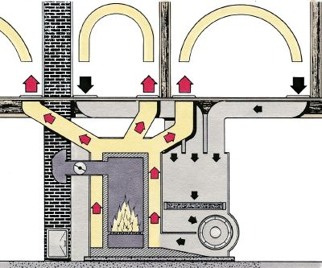

**©2006 PUBLICATIONS INTERNATIONAL, LTD. FORCED-AIR HEATING SYSTEMS USE A FAN TO MOVE WARM AIR.**

Once air is warmed or cooled at the heat/cold source, it must be distributed to the various rooms of your home. This can be accomplished with the forced-air, gravity, or radiant systems explained below.

Forced-Air Systems

A forced-air system distributes the heat produced by the furnace or the coolness produced by a central air conditioner through an electrically powered fan, called a blower, which forces the air through a system of metal ducts to the rooms in your home. As the warm air from the furnace flows into the rooms, colder air in the rooms flows down through another set of ducts, called the cold air return system, to the furnace to be warmed. This system is adjustable: You can increase or decrease the amount of air flowing through your home. Central air conditioning systems use the same forced-air system, including the blower, to distribute cool air to the rooms and to bring warmer air back to be cooled.

Problems with forced-air systems usually involve blower malfunctions. The blower may also be noisy, and it adds the cost of electrical power to the cost of furnace fuel. But because it employs a blower, a forced-air system is an effective way to channel airborne heat or cool air throughout a house.

Gravity Systems

Gravity systems are based on the principle that hot air rises and cold air sinks. Gravity systems, therefore, cannot be used to distribute cool air from an air conditioner. In a gravity system, the furnace is located near or below the floor. The warmed air rises and flows through ducts to registers in the floor throughout the house. If the furnace is located on the main floor of the house, the heat registers are usually positioned high on the walls because the registers must always be higher than the furnace. The warmed air rises toward the ceiling. As the air cools, it sinks, enters the return air ducts, and flows back to the furnace to be reheated.

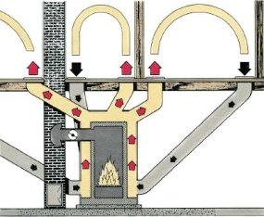

**©2006 PUBLICATIONS INTERNATIONAL, LTD. GRAVITY SYSTEMS RELY ON WARM AIR RISING NATURALLY.**

Another basic distribution system for heating is the radiant system. The heat source is usually hot water, which is heated by the furnace and circulated through pipes embedded in the wall, floor, or ceiling.

Radiant Systems

Radiant systems function by warming the walls, floors, or ceilings of rooms or, more commonly, by warming radiators in the rooms. These objects then warm the air in the room. Some systems use electric heating panels to generate heat, which is radiated into rooms. Like gravity wall heaters, these panels are usually installed in warm climates or where electricity is relatively inexpensive. Radiant systems cannot be used to distribute cool air from an air conditioner.

Radiators and convectors, the most common means of radiant heat distribution in older homes, are used with hot water heating systems. These systems may depend on gravity or on a circulator pump to circulate heated water from the boiler to the radiators or convectors. A system that uses a pump, or circulator, is called a hydronic system.

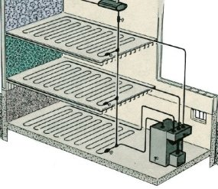

**©2006 PUBLICATIONS INTERNATIONAL, LTD. RADIANT HEATING SYSTEMS FUNCTION BY WARMING WALLS, FLOORS, OR CEILINGS, WHICH THEN WARM THE SURROUNDING AIR.**

Modern radiant heating systems are often built into houses constructed on a concrete slab foundation. A network of hot water pipes is laid under the surface of the concrete slab. When the concrete is warmed by the pipes, it warms the air that contacts the floor surface. The slab need not get very hot; it will eventually contact and heat the air throughout the house.

Radiant systems -- especially when they depend on gravity -- are prone to several problems. The pipes used to distribute the heated water can become clogged with mineral deposits or become slanted at the wrong angle. The boiler in which water is heated at the heat source may also malfunction. Hot water systems are seldom installed in new homes.

From: https://home.howstuffworks.com/home-improvement/heating-and-cooling/heating-and-cooling-system-basics-ga1.htm